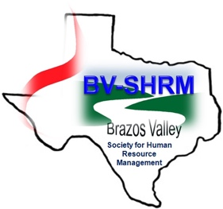

Krystal Broussard HR Award of Excellence

PURPOSE OF AWARDS PROGRAM
The BV-SHRM Krystal Broussard HR Award of Excellence program recognizes and rewards an outstanding HR Professional for his/her accomplishments within the organization, advancing the HR Profession, and providing service to the community as a HR Practitioner.

ELIGIBILITY CRITERIA
Eligible candidates will be working in a professional capacity with an organization in an employment relationship where the primary responsibilities are in the area of Human Resources.

Elected Board members serving in an Officer Role (President, President Elect, Secretary, Treasurer, VP Programs, VP Membership), are not eligible for award selection.

Prior recipients are eligible for re-nomination four years following receipt of award.

DESCRIPTION OF AWARDS
The candidate selected to receive the Krystal Broussard HR Award of Excellence will be presented a plaque and a $250.00 donation to the SHRM Foundation will be made in the recipient’s name. The award will be presented at the annual December BV-SHRM holiday luncheon and award program. The recipient will also receive public recognition through the chapter newsletter, BV-SHRM website, and other media.

EVALUATION PROCESS
A selection committee will review nominations and select the Award recipient based on the merits of the Nominee’s contributions as detailed in the nominator’s responses to the questionnaire. Nomination information will be presented to the selection committee without identifying information about the nominee, to ensure unbiased decisions based on the merits of the nominations.

SELECTION COMMITTEE MEMBERSHIP
The selection committee includes elected board members and the previous year’s award recipient. Selection committee members who submit a nomination are not eligible to participate in the selection process.

NOMINATION PROCESS
The supervisor, manager or director who is familiar with the Nominee’s contributions to the organization shall complete the Nomination Cover Sheet and Award Criteria Questionnaire. The Nominator may select one additional individual who is familiar with the Nominee’s contributions to complete the Award Criteria Questionnaire for extra supporting detail. The Award Criteria Questionnaire should not include any identifying information about the nominee include name, title, company or organization. All identifying information should be on the cover sheet only.

Nomination materials and forms (the Nomination Packet) must be received by October 27, 2017, for the selection committee to consider the nomination. Nomination materials received after close of business on October 27, 2017 will not be reviewed, and will not be returned. Once a complete Nomination Packet is received, the Selection Committee will forward a Nominee Information Request Form to the nominee for additional information.

For questions related to the nomination process, please contact Kris Lorch at klorch@suddenlink.net or 979-571-2445.

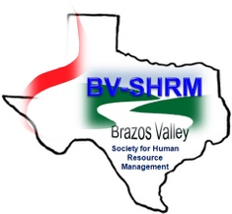

Krystal Broussard HR Award of Excellence
Nomination Cover Sheet

Deadline: Friday, October 27, 2017
NOMINEE INFORMATION
Name | Title
Company | Telephone | Years with Organization

NOMINATOR INFORMATION (Note: A nomination submitted by e-mail will be considered a signature by the sender.)
Nominator Name & Title | Telephone | Email
Signature |  | Date

SUPPORT INDIVIDUAL (Notes: This form may be forwarded to the Support Individual by the Nominator. A nomination submitted by e-mail will be considered a signature by the sender.)
Name of Support Individual | Signature

NOMINATION AWARD BENEFIT
Nomination Cover Sheet Public Recognition
Nominator’s Response Award Plaque
Support Response $250 SHRM Foundation Donation

(Submit Original Nomination Materials Only – No Extra Copies Required)

Return nomination packet via:
mail to
BV-SHRM
Attn: Award Committee
PO Box 3442
Bryan, TX 77805-3442
or
E-mail to klorch@suddenlink.net

Award will be presented at the BV-SHRM December Luncheon

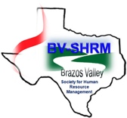
Krystal Broussard HR Award of Excellence
Award Criteria Questionnaire

This part of the nomination process will be evaluated on the merits of the nomination only. Please do not include the nominee’s name, title, company or other identifying information on this questionnaire. The nominator completes this questionnaire, and can enlist one support individual to substantiate the nomination by completing a separate questionnaire. If additional space is needed, attach up to one additional page per questionnaire. Return the nomination packet to BV-SHRM, Attn: Award Committee, P. O. Box 3442, Bryan, TX 77805-3442 or email to klorch@suddenlink.net.

Name of Person Completing Form:

1) How has your nominee contributed to the organization’s goals/objectives and provided distinguished service in the area of Human Resources? (Please do not include the nominee’s name, title or organization in your response.)

2) What actions has your nominee taken to promote the role of Human Resources in your organization and advance the Human Resources Profession? (Please do not include the nominee’s name, title or organization in your response.)

3) Describe in detail how your nominee cultivates effective professional relationships, promotes positive morale, inspires teamwork and displays an attitude of support to others. (Please do not include the nominee’s name, title or organization in your response.)

4) Provide examples of how your nominee has demonstrated service outside the scope of normal job responsibilities? (Please do not include the nominee’s name, title or organization in your response.)

